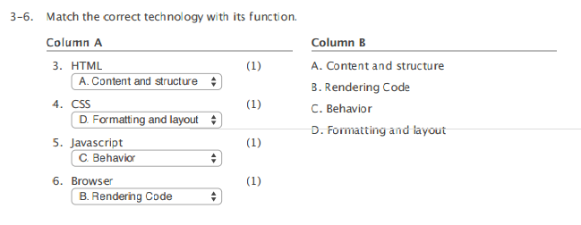3. How do you add a background color for all <h1> elements on a page (e.g., <h1>This is a header</h1>)?

* all.h1 {background-color:#FFFFFF}
* h1.all {background-color:#FFFFFF}
* **h1 {background-color:#FFFFFF}**
* h1#all {background-color:#FFFFFF}

A relative positioned element still takes up space in the normal flow, even if it is shifted to overlap with another element.

**True** False

HTML can be generated by Javascript code, and Javascript code can be embedded inside of an HTML page.

**True** False

In the following CSS code, what is the word "body" called? body { font-family: ariel, sans-serif; font-size: 100%; }

**Selector** Property Value Pseudo-class

In the normal flow, block elements (e.g., a div) stack horizontally and wrap around to the next line when they reach the right edge of the browser.

True **False**

Which of the following statements is NOT true of the Document Object Model

* **It is a subset of the Javascript language.**
* It represents elements as nodes on a tree.
* It is used by all of the major browsers in use today.
* It can be used to dynamically access, delete, and modify HTML documents.

The document object model treats HTML elements as a "tree" (e.g., an element such as <p> </p> can have a parent, a child, and/or siblings)

**True** False

Which of the following is NOT true of JSON?

* It is a language-neutral syntax for storing textual information
* It uses { } to define objects
* **It uses ; to separate items within an array**
* It uses [ ] to define arrays

An HTML document includes the following line:

<p id="header">this is the header text</p>

The following Javascript is executed within a script tag at the bottom of the page.

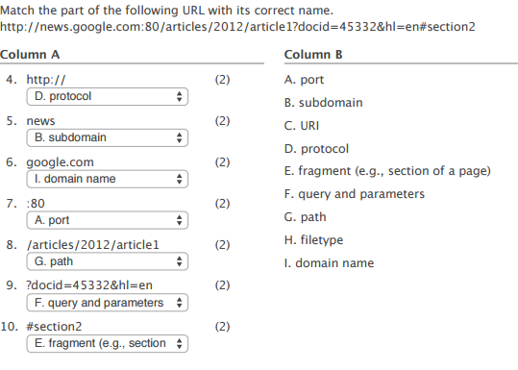document.getElementById("header").innerHTML = "hi there"

Which of the following is NOT true

* The page will display "hi there" on the page
* **If looking at the source of the page it will show the text "hi there" inside of the p tags instead of "this is the header text"**
* The getElementById("header") portion of the Javascript is a Method of the document object
* The javascript uses . notation

The Internet is;

* A centralized world-wide network connecting computers around the world and centrally controlled by W3C
* An extension of the world-wide web which includes dynamic interaction based on an "architecture of participation"
* **A network of networks, connected around the world and without a single, central control point, which relies upon standard protocols.**
* The combination of the web (WWW) plus email and file-sharing

The Internet Protocol Suite (including IP, TCP, HTTP, etc.) is a direct implementation of the OSI model.

True **False**

Which Internet protocol is most like the OSI Transport layer (e.g., in charge of assuring that all packets are received)?

* **TCP**
* IP
* FTP
* HTTP

Which of the following is NOT a core property of the IP/TCP Internet Protocols.

* **They are designed to be as efficient as possible**
* They are vendor independent (i.e., no company owns them)
* They work with different network types
* They are resilient to broken links in the network

Each DNS server maintains a list of all Internet domains and their corresponding IP addresses on the Internet.

True **False**

Which is NOT true about the IP layer?

* IP packets may arrive out of order
* IP packets may not arrive at all
* **IP is a connection-oriented service that requires a session connection for packets to be sent and received**
* IP is most comparable to the network layer in the OSI model

Which of the following is NOT true of HTTP

* It is a protocol
* A web server is software that knows how to respond to HTTP requests
* HTTP is a pull protocol that is client initiated
* **HTTP is an object-oriented programming language**

As used in most web systems, PHP is interpreted/executed in the

* Browser
* Cloud
* **Web Server**
* Database serve

SQL is a Relational Database Management System.

True **False**

When a user enters malicious code into a web form that is then executed as an SQL query, it is called _____.

* **SQL Injection**
* Buffer Overflow
* Cross-Site-Scripting
* SQL Aversion

Which of the following is NOT true of PHP

* PHP is used for many content management systems like Wordpress, Drupal, and wikis like MediaWiki
* **PHP arrays must contain only one type of data (e.g., all integers; or all strings, but not both)**
* In PHP variables must start with a $
* In PHP variables found within single quotes (' and ') and double quotes (" and ") are treated differently

When viewing a webpage via a browser, viewing the source will show the PHP code.

True **False**

Which of the following is NOT true of PHP Sessions

* They include a unique identifier that is sent to the browser to be stored as a cookie
* They are removed after a certain amount of time (e.g., 15 minutes) of inactivity (i.e., when the browser does not make a request)
* They are stored in the $_SESSION variable
* **They are created by the client**

When .htaccess is turned on in Apache, the server must look for a .htaccess file in the directory of the file that is trying to be accessed, as well as its parent directories.

**True** False

Which of the following is NOT a use of .htaccess ?

* **Speeding up the execution of Javascript code**
* Blocking IP addresses from accessing a webpage
* Password protecting a webpage
* Customizing server error messages

Which of the following is NOT true of the GET method.

* Data is transmitted to the server via the query string
* **Binary data (i.e., and other non-ASCII data) should be sent via the GET method**
* Can be bookmarked
* Limited in number of characters that can be sent (compared to POST)

Data sent through the POST method is sent as part of the HTTP body, not the URL.

**True** False

Which protocol is used for sending email?

* **SMTP**
* POP3
* HTTP
* IMAP

Which of the following is NOT true of cookies?

* They are stored on the client
* **They are shared among browsers on the same computer**
* They have an experation date
* They can either be set by the domain you are visiting or a 3rd party domain

Which 2 services does HTTPS (i.e., SSL/TLS) provide when you connect to a server?

* **Identification (i.e., a 3rd party verifies that the server you are trying to talk to is who they say they are)**
* Availability (i.e., your connection to the server will remain available for the duration of your session)
* Integrity (i.e., the messages you send to the server cannot be tampered with or deleted)
* **Encryption (i.e., messages sent to and from the server you connect with are encrypted)**

Which of the following is NOT a strategy for helping deal with a shortage of IP addresses.

* **Switch from classless IP addresses (CIDR) to classful IP addresses (e.g., Class A, Class B...)**
* Dynamically assign IP addresses (e.g., using DHCP Servers) to members of a local network (e.g., an ISP's network).
* Use private local IP addresses that are all routed through a single public-facing IP address
* Add more bits to the next generation of IP addresses so more IP addresses will be available

It is impossible to recreate a document from its hash

**True** False

If a person buying an item on Amazon can plausibly deny that they received the item, there has been a breach in which information security service?

* Confidentiality
* Availability
* Non repudiation
* Integrity

SSL uses asymetric encryption, NOT symetric encryption

True **False It uses both**

Ping is a good measure of bandwidth

True **False**

Which of the following is responsible for the slowness of sending a text message to China from the US?

* **latency**
* bandwidth
* throughput
* content

A Denial of Service attack is a good example of a breach in Availability

**True** False

The User Agent (e.g., the browser that is requesting data) is passed within the header as part of the HTTP protocol.

**True** False

Which of the following is NOT part of total latency delay?

* **bandwidth delay**
* queue delay
* propigation delay
* proessing time delay

Asymetric (i.e., private key) encryption includes two keys. Either one can be used to encrypt data, and the other one will be used to decrypt the data.

**True** False

In the following SQL statement, "P_id" is the name of a column (i.e., field) in the tbl_people table.  
  
SELECT P_id, FirstName, LastName, Age  
        FROM tbl_people  
        WHERE Age > 18  
        ORDER BY LastName

**True** False